Modul-1

1)What is software ? and what is software engineering?

Software is a group of instruction. There is main 5 type of software .

-System software(ex.android,,IOS)

-application software(ex. meesho)

-driven software(ex.adio and video driven software)

-middleware(ex. microsoft)

-programming software(ex.vs code)

software engineering give the detail theory and practical knowledge of software .its give sdlc (software development life cycle )to develop reliable,fast and maintainable software.software engineering also contain the knowledge about software architecture its also know as blue print of software

2)Explain types of software

There is main 5 types of software

-System software:System software is provide the platform and enviroment to excute the other software

.ex-IOS,Window

-Application Software: Applicaation software is also set of instruction but only for particular task.ex-meesho

-Driver Software:example of driver software is audio software.

-Middleware:middleware is work like a intermidate .ex-Google Translate

-Programing Software:It's provide the enviroment to run and compaile the code.ex-vs code

3)What is SDLC?Explain each phase of SDLCL

SDLC means Software development life cycle.it's divided in 5 phases.each phase it's own importance.it's

help to develop the reliable ,manitanable and ease to use software

-Planning:It's the First Phase of SDLC.in this Phase,the developer and Customer decide What is Visible and What

is not Visible in software

-Analys:After the First step Analyze the overall planning and finalize the software Function and all.

-Design : in this phase create the blue print of the software for the easiness.

-implimantation : create the final software . this is ready to deploy.

- testing: after the implimantation test the final software .ckeck ther is any bug or not

-Maintainace: if the updation need then the Phase for the Maintainaceof the software

4)DFD for the Flipkart

-full from of DFD is data flow diagram . it’s three main level :0 level,1 Level,2 level

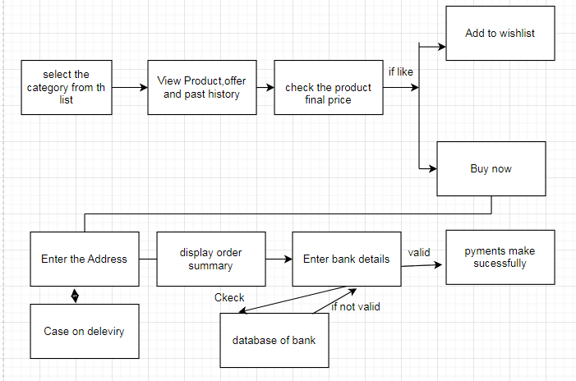

5) Flow chart

Flow chart diagram is Easiest diagram . it’s easily understand by technical and non technical person.it’s overcome the cons of Algorithm

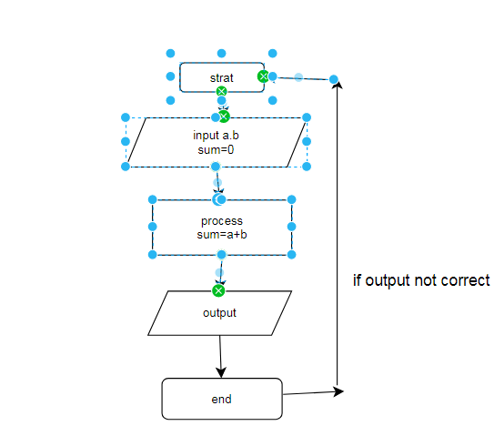

6)Use case diagram

Use case diagram is a diagram that’s define the particular task has complited by which person .

in this many user define by actore.

